- I have been confirmed as a victim of real name identity theft from the other credit bureaus, which is the most severe form, and it resonates from the illegal investor mortgage by Selene Financial LP being reported and needs to be blocked and removed.
- The address 927 SW 35th Street Lawton, OK 73505, should not be associated with my profile. It first appeared through an SSN Tracker Alert on Transunion on 11/28/2020. Again on 3/4/2022, 3/4/2024, and 6/28/2025 without my express authorization.
- The number of soft inquiries are alarming as they match the dates of unauthorized mortgages and financial obligations unrelated to me specifically but are to my Mother’s Debra Dunham credit profile in which Sovereign Bank and PennyMac illegally opened HELOC and FHA Mortgages on her property and others, or match county liens and release of liens filed in Comanche County Court Records that are disguised commercial mortgages from the same institutions. In any case, I would like every soft inquiry to be removed along with a full explanation from each of the creditors listed in the attached report as to why they inquired and were not using my SSN or real name.
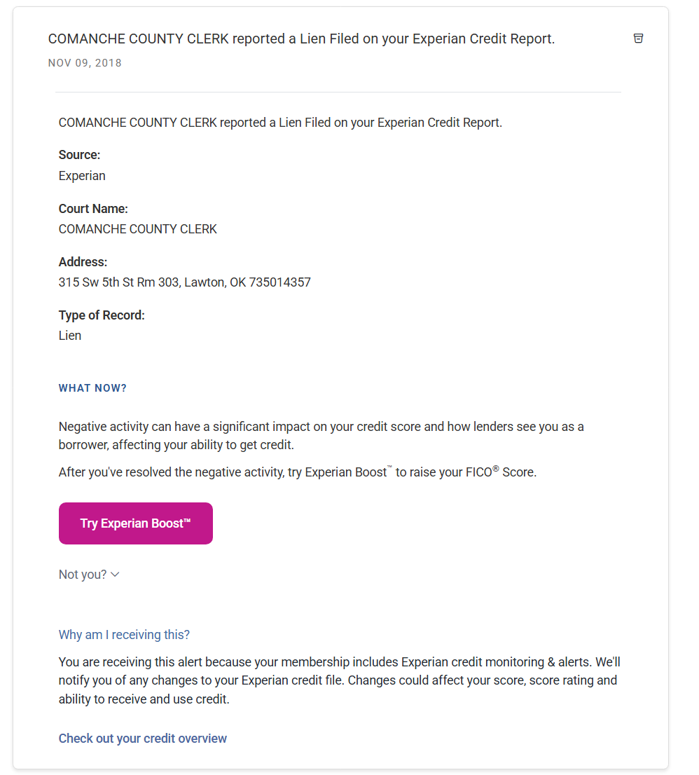
  - I sent an email to the county clerk about the picture above and never received a response. I then looked at the tax liens and releases on file and noticed that the amounts were wrong, the warrants did not match, it was a completely different document template/format, the amount were incorrect and one was missing.
- The name Devon Dunham has re-appeared in my report and is not my real name or anything I have ever applied for credit with. This is evidenced by an Experian alert on 1/23/2026 stating: Ran SSN against credit report data and lists 12 aliases:
    - Devon J Dunham
    - Devon J Dunhm
    - Devon Dunhm
    - Devon Dunham
    - 927 Sw 35th St, Lawton, OK 73505
    - 1530 P B Ln, Wichita Falls, TX 76302
    - 1530 Pv Ln Apt D9144, Lawton, TX 76302
    - 1316 Nw Sheridan Rd, Lawton, OK 73505
    - 4413 121st Ln, Lubbock, TX 79424
    - 370 Us Highway 87, Lubbock, TX 79423
    - 7007 Sw Stradford Ave Apt B, Lawton, OK 73505
    - 9404 Northland Rd, Oklahoma City, OK 73120
- 1/23/2026 shows inquiries and loans that are not reported on my Experian report as “We searched for alternative lending activity under your personal info”
    - 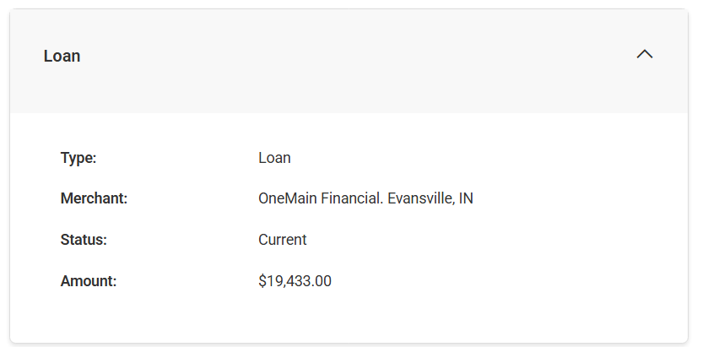
    - 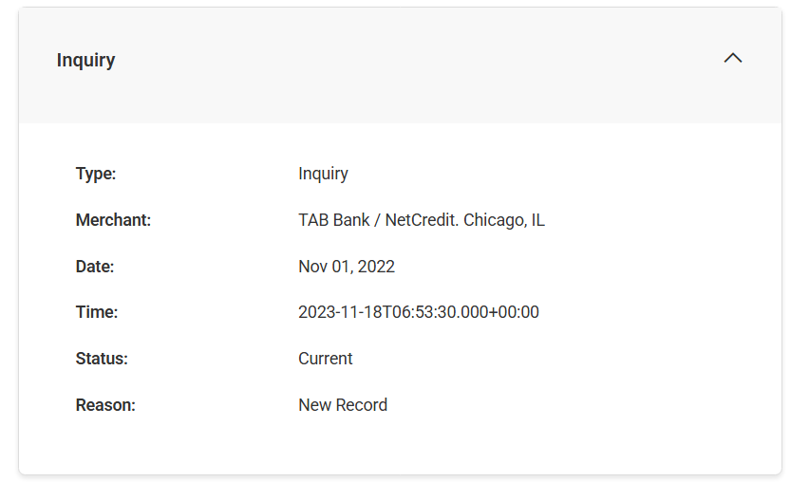
    - 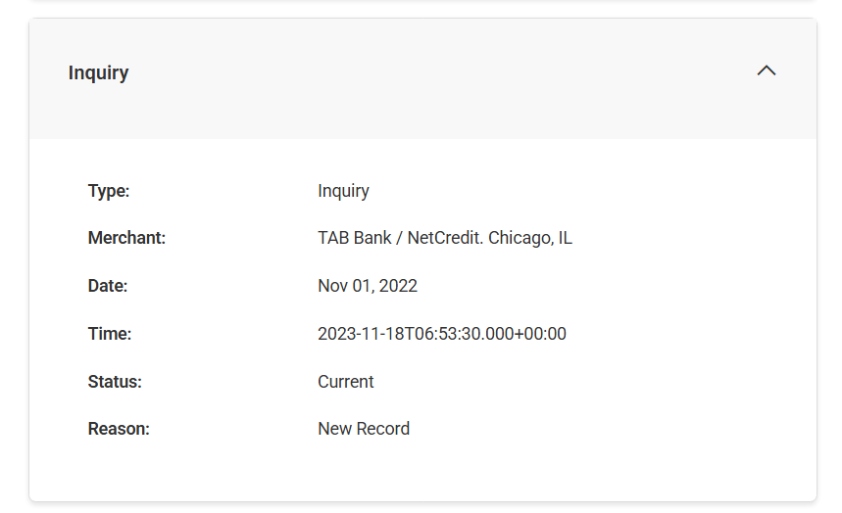
    - 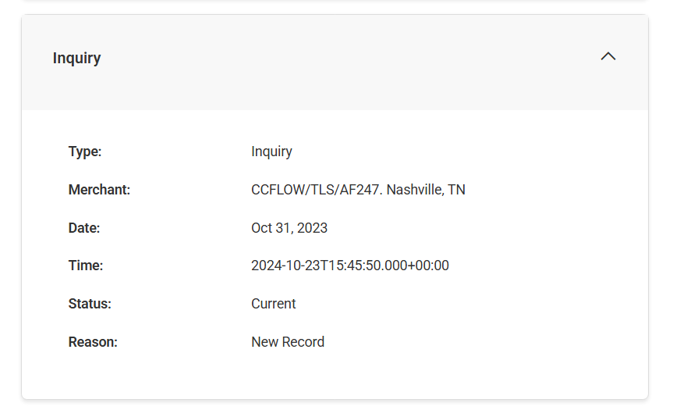
    - 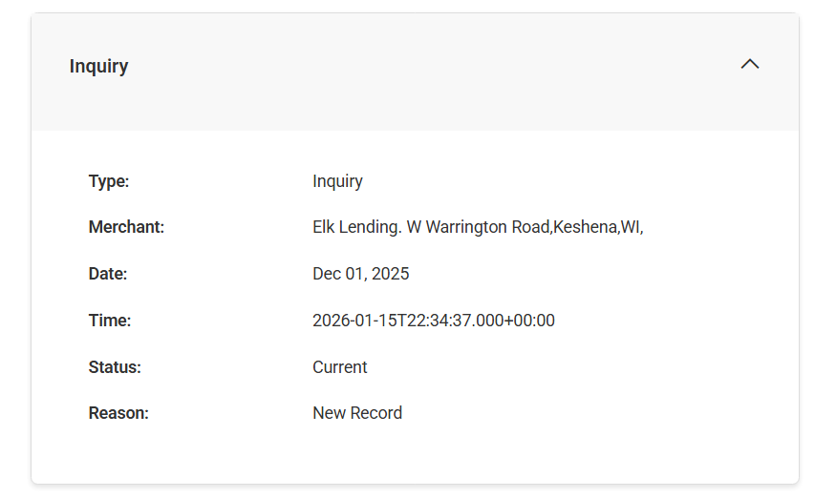
    - 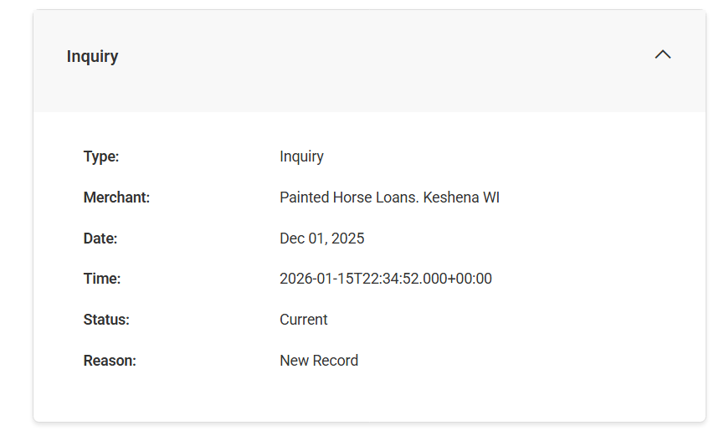
    - 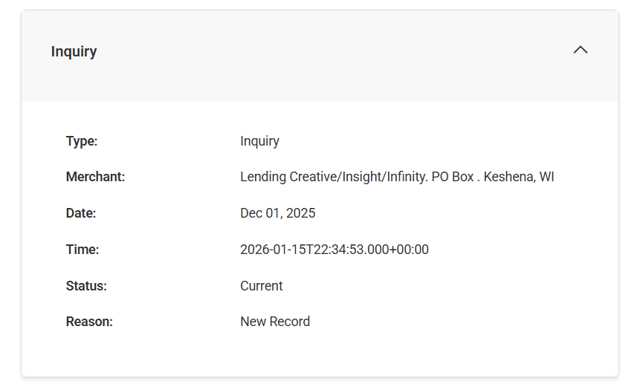
    - 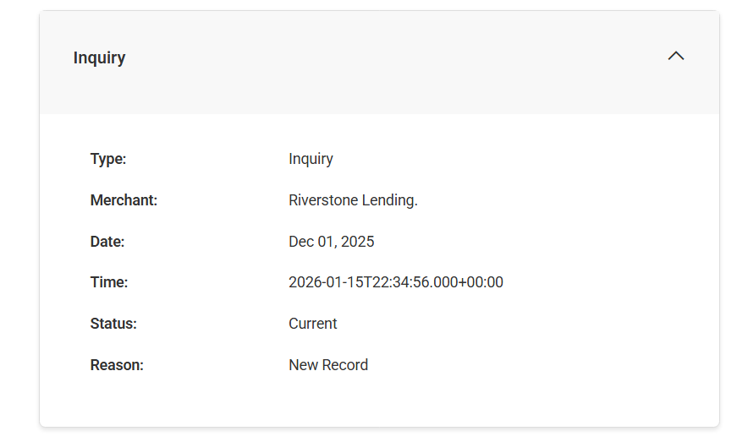
    - 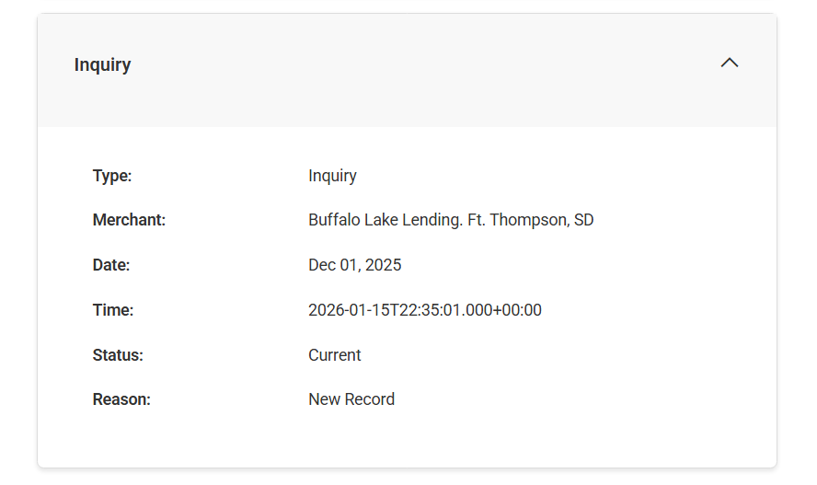
    - 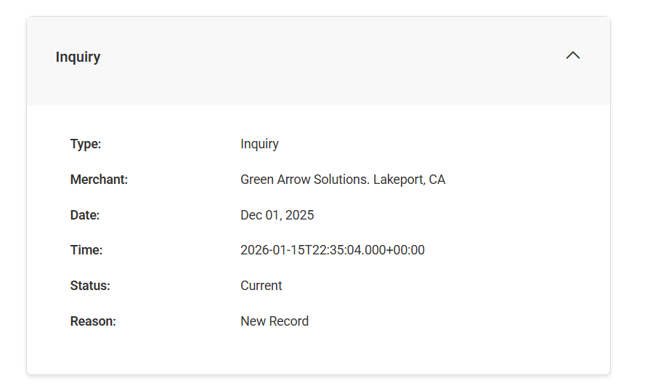
- Selene Finance LP according to Experian is still reporting as Selene Finance LLC on Equifax and Transunion with mis-match balances and terms. Transunion says that is is $470/mo. For 40 months. Equifax clearly shows that a new mortgage has been opened and overlapped the previous one by showing the codes and has been blocked from my report. The balance was updated in March along with the payment history showing that a payment was made and it was not made at that time. The payment that was made illegally matched the corporate and suspense fees attached to the monthly statement and was promptly returned due to fraud by my financial institution. They continue to update and change the 30-day flag on the December and January months as they are separate illegal mortgages.
  - 1/10/26 SELENE FINANCE LP has flagged your account as 30 Days Past Due with balance of 62051
  - On 1/29/26 the Experian account was disputed on report 7917-5055-00 with a statement that: The account with SELENE FINANCE LP that starts with 271200XXXXXXX has not been changed and will remain on your credit report. But the company address was: 3501 Olympus Blvd Fl 5, Coppell, TX 75019
  - On 2/1/26 the Experian alert states: SELENE FINANCE LP reported a new account on your TransUnion Credit Report and reports an address: Attn Customer Service Research P.o. Box 8279, Philadelphia, PA 19101 and balance of $61642 which currently does not match what is being reported on transunion.
- On January 18, 2020, a Liberty national bank account was opened according to my Experian alerts that I did not apply for.
- 1/23/2026 there were 66 items from “Ran info against dark web”
- I am not responsible for the 27+ OneMain Inquiries from report 4939-7524-60. The 29 soft inquiries below are concerning as they relate to real name identity theft from unauthorized accounts that do not belong to me and should be removed.
- Spoke with Experian on case # Dispute 194621928 to remove address, name alias, flag nationstar, remove 4 soft inquiries, and opt-out from pre-screening.
- Something changed on my credit report between 3/4/2026 and 3/17/2026 with hard queries from Capital One which were removed and prove that I am a victim of severe real name identity theft and should expedite the closing and removal and block of all Capital One accounts currently under dispute and all soft inquiries.
- I just logged into Experian and it sent me the text message for 2-factor and showed a number that is not associated with my account.
- I evicted an unruly renter and called the Lawton Police Department only to have them take my passport card and issue a citation with mismatching personal identifiable information that created a profile based on privileged information I did not provide such as the address, my signature, a commercial vehicle description or VIN number. A few days later I went to retrieve the police reports for my record and discovered that there was a report opened in my name on 3/11/2026 that I was unaware of and was not given access to due to it being under investigation for fraud.
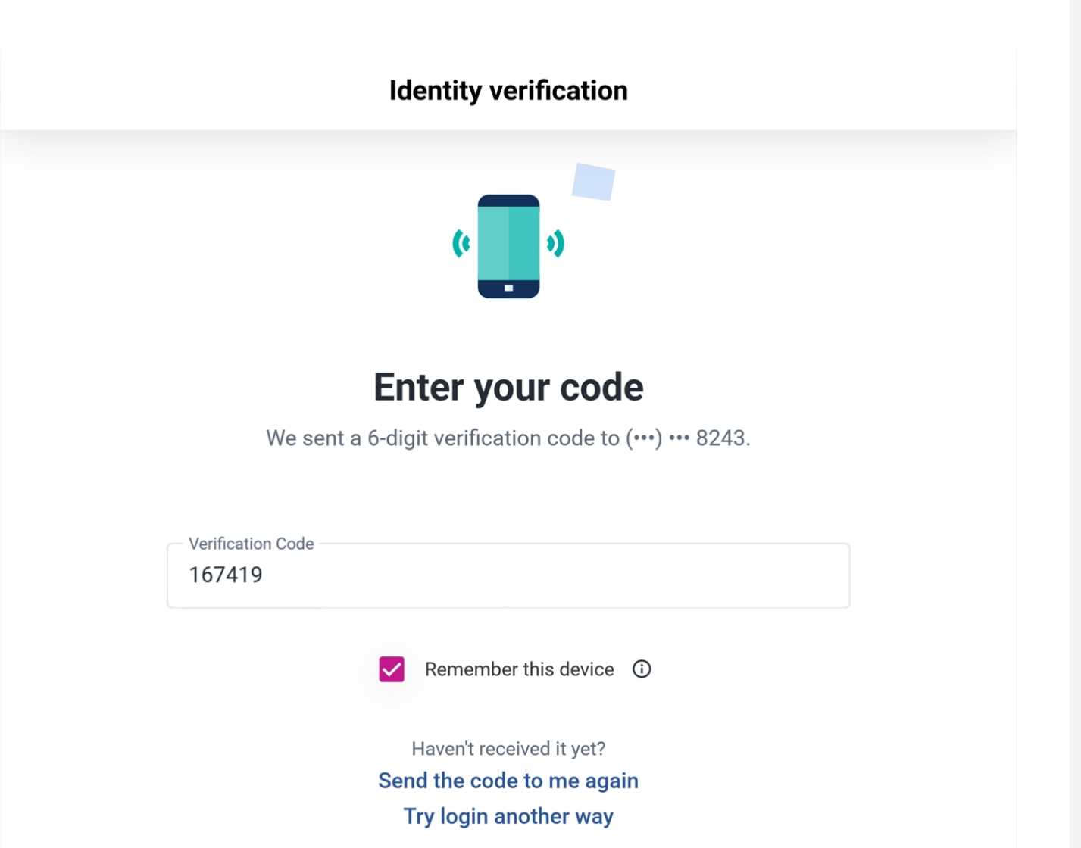

- ALERT I PH/EXPERIAN
Inquired on 02/21/2026 and 02/06/2026
701 EXPERIAN PKWY, ALLEN TX 75013
(888) 397-3742
On behalf of 5802846839
- AMERICAN EXPRESS
Inquired on 05/20/2025
5301 MCCONNELL RD, WHITSETT NC 27377
(800) 874-2717
- CAPITAL ONE
Inquired on 03/07/2026
15000 CAPITAL ONE DR, RICHMOND VA 23238
- CAP ONE NA

Inquired on 05/30/2025
1500 CAPITAL ONE DRIVE, RICHMOND VA 23285
- CAPITAL ONE
Inquired on 05/30/2025
15000 CAPITAL ONE DR, RICHMOND VA 23238
- CLARITY/ADVANCE AMERICA

Inquired on 09/12/2025 , 09/09/2025 and 03/31/2025
135 N CHURCH ST, SPARTANBURG SC 29306
- CLARITY/ELK LENDING-TPSI
Inquired on 09/10/2025
W2818 WARRINGTON ROAD, KESHENA WI 54135
- CLARITY/THREE STICKS LEN

Inquired on 03/31/2025
27565 RESEARCH PARK DR, MISSION SD 57555
(844) 328-1024
- CONSUMERINFO.COM
Inquired on 05/27/2025
475 ANTON BLVD, COSTA MESA CA 92626
- CONTINENTAL FINANCE COMP

Inquired on 08/20/2025 , 07/18/2025 , 06/25/2025 and 03/26/2025
4550 NEW LINDEN HILL RD #400, WILMINGTON DE 19808
- EXPERIAN
Inquired on 03/17/2026 , 03/16/2026 , 03/15/2026 , 03/14/2026 , 03/13/2026 , 03/12/2026 , 03/11/2026 , 03/09/2026 , 03/06/2026 , 03/05/2026 , 03/04/2026 , 03/03/2026 , 03/02/2026 , 03/01/2026 , 02/27/2026 , 02/26/2026 , 02/25/2026 , 02/24/2026 , 02/23/2026 , 02/21/2026 , 02/20/2026 , 02/19/2026 , 02/16/2026 , 02/13/2026 , 02/12/2026 , 02/06/2026 , 02/04/2026 , 02/03/2026 , 01/29/2026 , 01/17/2026 , 05/06/2025 , 04/19/2025 , 04/18/2025 and 04/17/2025
PO BOX 9600, ALLEN TX 75013
(800) 311-4769
CAPS API DISCLOSURE
- EXPERIAN

Inquired on 03/13/2026 , 03/09/2026 , 03/05/2026 , 02/21/2026 , 02/17/2026 , 02/06/2026 , 01/22/2026 , 01/19/2026 , 01/17/2026 , 01/09/2026 , 01/06/2026 , 12/24/2025 , 12/05/2025 , 11/27/2025 , 11/21/2025 , 11/15/2025 , 11/12/2025 , 11/06/2025 , 10/29/2025 , 10/23/2025 , 10/21/2025 , 10/02/2025 , 08/28/2025 , 08/21/2025 , 08/19/2025 , 08/02/2025 , 07/15/2025 , 07/02/2025 , 06/25/2025 , 06/18/2025 , 06/17/2025 , 05/30/2025 , 05/29/2025 , 05/24/2025 , 05/19/2025 , 05/13/2025 , 05/08/2025 , 05/03/2025 , 04/11/2025 , 03/26/2025 and 03/19/2025475 ANTON BLVD, COSTA MESA CA 92626
- EXPERIAN
Inquired on 03/09/2026 , 03/05/2026 , 02/23/2026 , 02/12/2026 , 02/09/2026 , 02/06/2026 , 02/05/2026 , 02/04/2026 , 02/03/2026 , 02/01/2026 , 01/30/2026 , 01/29/2026 , 01/28/2026 , 01/26/2026 , 01/25/2026 , 01/23/2026 , 01/19/2026 , 01/17/2026 , 01/12/2026 , 01/11/2026 , 01/05/2026 , 12/29/2025 , 12/22/2025 , 12/15/2025 , 12/08/2025 , 12/01/2025 , 11/24/2025 , 11/17/2025 , 11/10/2025 , 11/03/2025 , 10/27/2025 , 10/13/2025 , 10/08/2025 , 10/06/2025 , 09/29/2025 , 09/22/2025 , 09/17/2025 , 09/15/2025 , 09/12/2025 , 09/09/2025 , 09/08/2025 , 09/03/2025 , 09/02/2025 , 09/01/2025 , 08/31/2025 , 08/29/2025 , 08/27/2025 , 08/26/2025 , 08/25/2025 , 08/18/2025 , 08/17/2025 , 08/14/2025 , 08/11/2025 , 08/09/2025 , 08/04/2025 , 08/03/2025 , 07/30/2025 , 07/29/2025 , 07/28/2025 , 07/26/2025 , 07/24/2025 , 07/16/2025 , 07/15/2025 , 07/14/2025 , 07/10/2025 , 07/09/2025 , 07/08/2025 , 07/06/2025 , 07/05/2025 , 07/02/2025 , 06/30/2025 , 06/29/2025 , 06/26/2025 , 06/23/2025 , 06/22/2025 , 06/20/2025 , 06/17/2025 , 06/16/2025 , 06/15/2025 , 06/14/2025 , 06/13/2025 , 06/12/2025 , 06/09/2025 , 06/03/2025 , 06/02/2025 , 05/30/2025 , 05/29/2025 , 05/26/2025 , 05/20/2025 , 05/19/2025 , 05/15/2025 , 05/12/2025 , 05/09/2025 , 05/06/2025 , 05/05/2025 , 04/28/2025 , 04/21/2025 , 04/19/2025 , 04/18/2025 , 04/17/2025 , 04/16/2025 , 04/15/2025 , 04/14/2025 , 04/07/2025 , 03/31/2025 , 03/24/2025 and 03/17/2025
475 ANTON BLVD, COSTA MESA CA 92626
(866) 431-3471
- EXPERIAN

Inquired on 02/06/2026
475 ANTON BLVD, COSTA MESA CA 92626
- EXPERIAN
Inquired on 05/27/2025
475 ANTON BLVD, COSTA MESA CA 92626
- EXPERIAN

Inquired on 05/27/2025
PO BOX 9600, ALLEN TX 75013
(800) 311-4769
- EXPERIAN CREDITMATCH
Inquired on 02/09/2026 , 02/06/2026 , 02/04/2026 , 02/03/2026 , 02/01/2026 , 01/29/2026 , 01/28/2026 , 01/26/2026 , 01/25/2026 , 01/23/2026 , 01/19/2026 , 01/17/2026 , 01/11/2026 , 09/12/2025 , 09/03/2025 , 08/25/2025 , 08/14/2025 , 08/09/2025 , 07/30/2025 , 07/26/2025 , 07/15/2025 , 07/14/2025 , 07/09/2025 , 07/06/2025 , 06/30/2025 , 06/22/2025 , 06/12/2025 , 05/27/2025 , 05/26/2025 , 04/19/2025 , 04/18/2025 , 04/17/2025 and 04/15/2025
475 ANTON BLVD # D4, COSTA MESA CA 92626
- EXPERIAN CS IDENTITY

Inquired on 02/16/2026 , 01/16/2026 , 12/16/2025 , 11/16/2025 , 10/16/2025 , 09/16/2025 , 08/16/2025 , 07/16/2025 , 06/16/2025 , 05/16/2025 , 04/16/2025 and 03/16/2025
535 ANTON BLVD STE 100, COSTA MESA CA 92626
- ID ME INC
Inquired on 06/14/2025
8281 GREENSBORO DR STE 600, TYSONS CORNER VA 22102
(866) 775-4363
- INTUIT INC
Inquired on 02/24/2026
2700 COAST AVE, MOUNTAIN VIEW CA 94043
- NATIONAL FUNDING

Inquired on 07/30/2025
4380 LA JOLLA VILLAGE DR, SAN DIEGO CA 92122
(888) 733-2383
- NAV TECHNOLOGIES INC
Inquired on 03/06/2026 , 03/05/2026 , 02/21/2026 , 02/18/2026 , 02/16/2026 , 02/13/2026 , 02/06/2026 , 01/22/2026 , 01/19/2026 , 01/09/2026 , 01/06/2026 , 12/17/2025 , 12/05/2025 , 11/27/2025 , 11/06/2025 , 10/29/2025 , 10/08/2025 , 09/27/2025 , 08/19/2025 , 08/18/2025 , 08/12/2025 , 08/02/2025 , 06/18/2025 , 05/30/2025 , 05/19/2025 , 05/08/2025 , 04/18/2025 , 03/26/2025 , 03/21/2025 , 03/19/2025 and 03/12/2025
13693 S 200 W STE 200, DRAPER UT 84020
(855) 226-8388
- NAV TECHNOLOGIES INC

Inquired on 03/24/2025
12936 S FRONTRUNNER BLVD # 550, DRAPER UT 84020
- NOVO PLATFORM INC
Inquired on 02/26/2026
123 WILLIAMS ST, FL 19, NEW YORK NY 10038
(844) 260-6800

- NOVO PLATFORM INC
Inquired on 09/24/2025 , 08/26/2025 , 07/22/2025 , 06/24/2025 and 04/30/2025
123 WILLIAMS ST, FL 19, NEW YORK NY 10038
(844) 260-6800
COLLECTION
- REPRISE FINANCIAL

Inquired on 07/29/2025 , 07/01/2025 and 05/27/2025
PO BOX 143454, IRVING TX 75014
(855) 475-6767
- RESURGENT CAPITAL SERVIC
Inquired on 04/08/2025
PO BOX 10497, GREENVILLE SC 29603
(866) 464-1183
- SEEN FINANCE INC

Inquired on 08/05/2025 , 07/10/2025 and 06/09/2025
1193 W 2400 S, WEST VALLEY CITY UT 84119
(833) 923-7336
- ZILLOW INC
Inquired on 08/18/2025
1301 2ND AVE FL 36, SEATTLE WA 98101
(206) 470-7000

